

Assignment 2



**TDS 3751**

**(SOCIAL MEDIA COMPUTING)**

Analyzing User Sentiment towards Industries and Brands

|  |  |  |
| --- | --- | --- |
| **Name** | **Student ID** | **Tutorial Group** |
| Nur Farisha Shahirah Binti Abdul Rahman | 1171302013 | TT02 |
| Nur Fadhilah Binti Roslee | 1161100442 | TT02 |
| Raden Ameer Hanafi Bin Hambali | 1171302475 | TT02 |

# INTRODUCTION

Sentiment Analysis is an important aspect to understand the users’ perception of industries, brands, and associated topics.

# Industry: Pizza Chains

The industry that’s been studied is the Pizza Chains, mainly from the USA user’s perspective. Pizza is known as a staple food in the USA. Consumers have different opinions on the pizza chains industry, based on a sample of fifty thousand extracted tweets, the sentiments for the pizza chain industry are as follows. Based on the graph of sentiments percentage below, most of the users have neutral opinions on the pizza industry, followed by positive opinions.

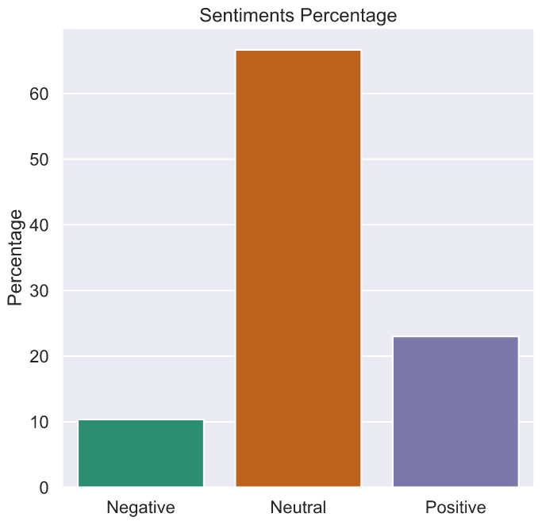

The positive and negative sentiments are analyzed further to study what are the factors that lead to their respective sentiments. The word frequencies in positive and negative sentiments are as shown in figure below.

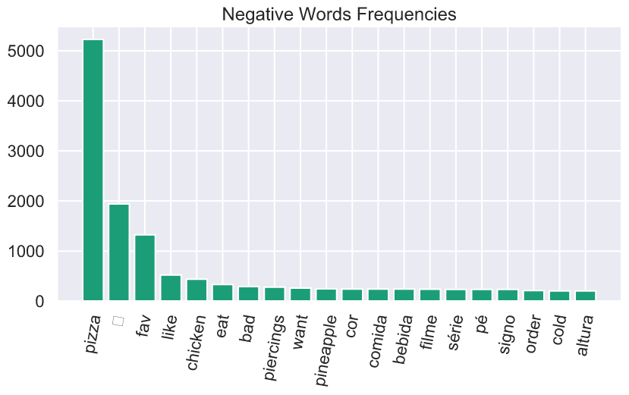 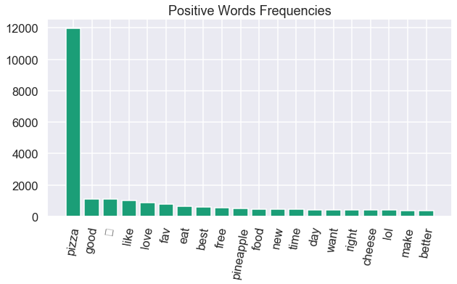

From the figures above, it is shown that the negative opinion mostly is on the chicken pizza, and “bad” keyword that is assumed due to bad taste. As for the positive sentiments, the keywords are “best”, “free”, and “new”, which are usually correlated with new menu or promotions. The keyword “cheese” is also one of the top keywords as most people like the cheese on their pizza.

# Popular Brands

The popularity of the pizza chain brands are determined by the number of brand’s name mentioned, the demographic of the twitter account, and the engagement analysis. There are five popular pizza chain brands that we analyzed based on the search keyword, which are Dominos, Pizzahut, Little Caesars, Papa John’s, and California Pizza Kitchen. The demographic for each brand are shown in the table below.

|  |  |  |  |  |
| --- | --- | --- | --- | --- |
| **Brand name** | **Year Joined** | **Status Count** | **Followers Count** | **Friends Count** |
| Dominos | 2009 | 407852 | 1319747 | 571 |
| Pizzahut | 2007 | 441641 | 1625253 | 88367 |
| Little Caesars | 2009 | 44546 | 311635 | 921 |
| Papa John’s | 2008 | 63445 | 630311 | 2757 |
| California Pizza Kitchen | 2009 | 24163 | 35767 | 317 |

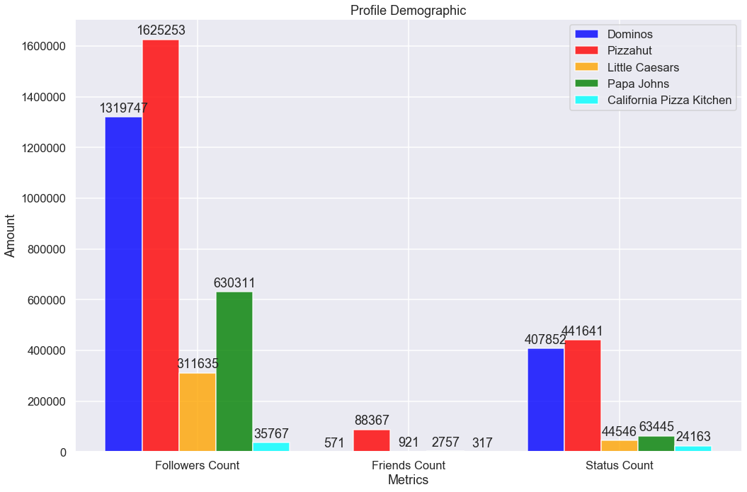

Based on the figure above, Pizzahut is the first pizza chain to join twitter and has the most status, followers, and friends count compared to other brands. The ranking of the followers and status count after Pizzahut are followed by Dominos, Papa Johns, Little Caesar’s and California Pizza Kitchen respectively.

The popularity of a brand is then analyzed by the number of extracted tweets based on the brand’s name as search keyword. The number of extracted tweets is as shown in the table below.

|  |  |  |  |  |  |
| --- | --- | --- | --- | --- | --- |
| Brand | Dominos | Pizzahut | Little Caesar’s | Papa John’s | California Pizza Kitchen |
| Number of user mentioned |  |  |  |  |  |

Based on the table above, Dominos has the highest number of mentions. This shows how dominos is the most talked pizza chain brand among customers. Furthermore, the figure below shows the engagement analysis of all five brands. As expected, Dominos has the most mentions, favourite and retweet counts. The second-highest number of retweets and favourite is by Little Caesar’s, which shows they have active customers on twitter as well.

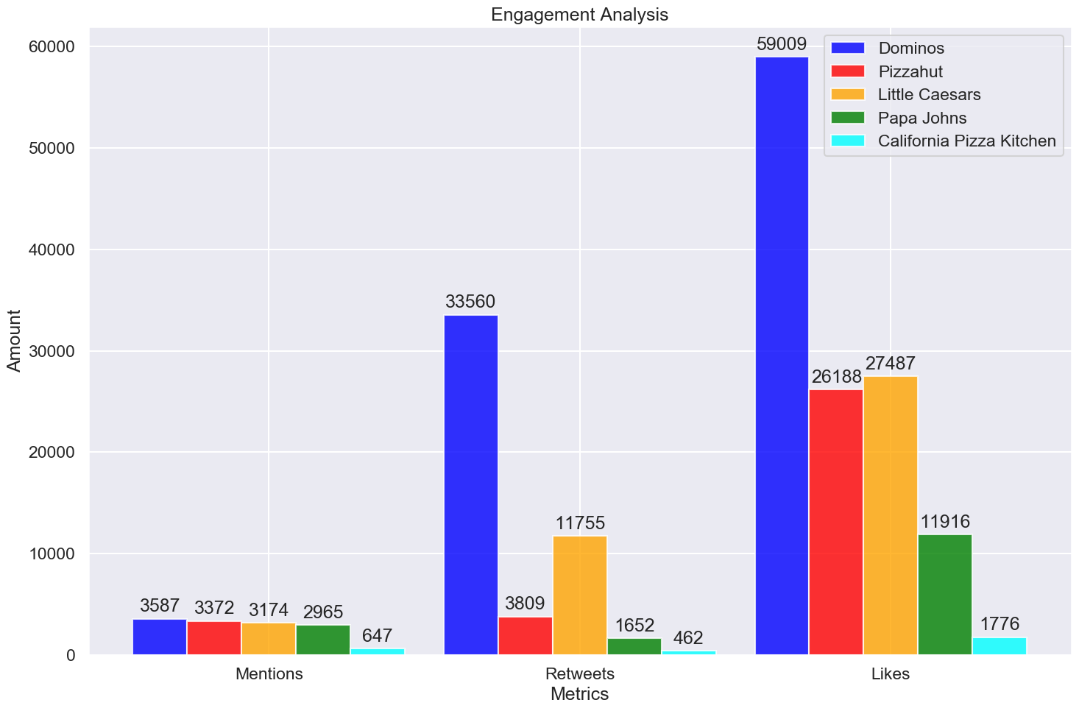

# Brand Sentiments

Dominos:

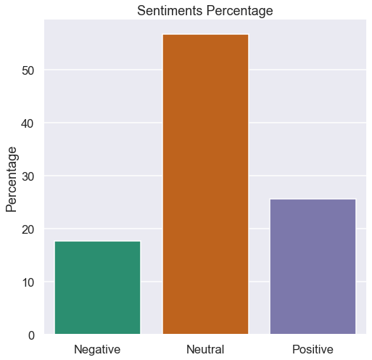

Pizzahut:

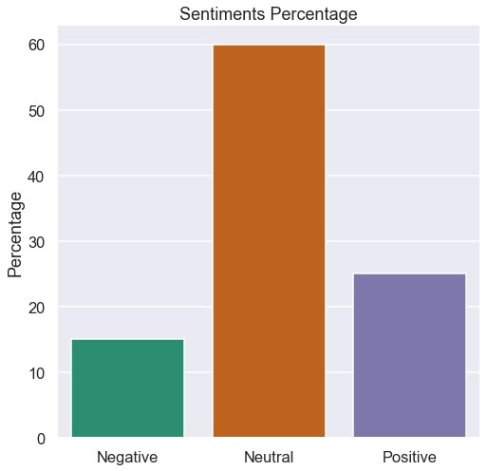

Little Caesar’s:

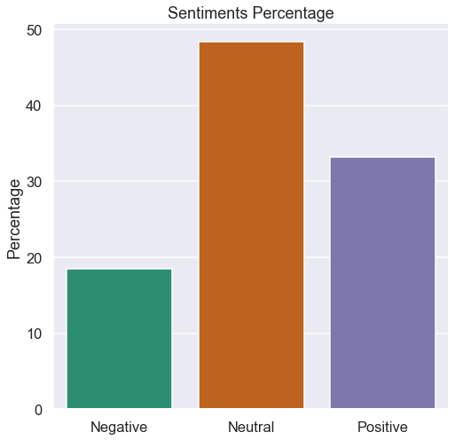

Papa John’s:

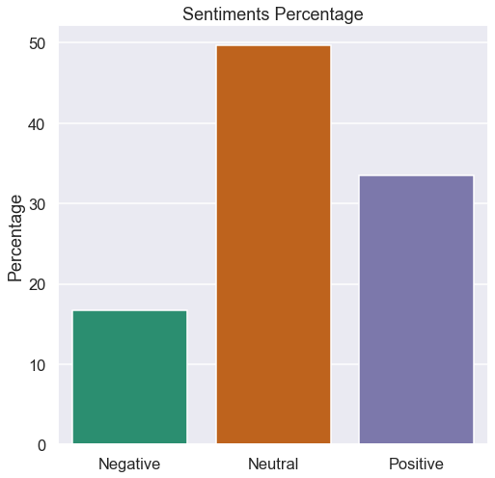

California Pizza Kitchen:

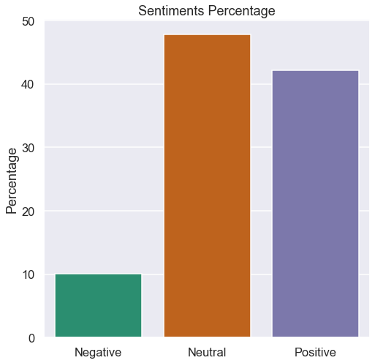

# Overall, the pattern for all the pizza brands is the same. Users have a neutral sentiment towards all the pizza brands, followed by positive sentiment and lastly followed by negative sentiments. This is considered good because the negative sentiments do not top both neutral and positive sentiment. But to be better, all the pizza brands should try to make positive sentiments top the rest because if they succeed in doing so, that means they successfully wins the user hearts.

# Despite having the same pattern, California Pizza Kitchen may show the best results because the positive sentiment percentage is close to the neutral sentiment compared to the rest.

# Hot Topics

The interaction between users and the pizza chain brand on twitter is mostly for customer services and promotions. The frequent topics mentioned by users are evaluated by how many times the words appear in the dataset.

**Positive sentiment:** From top left (Papa John, Pizza Hut, Little Caesars and California Pizza Kitchen)

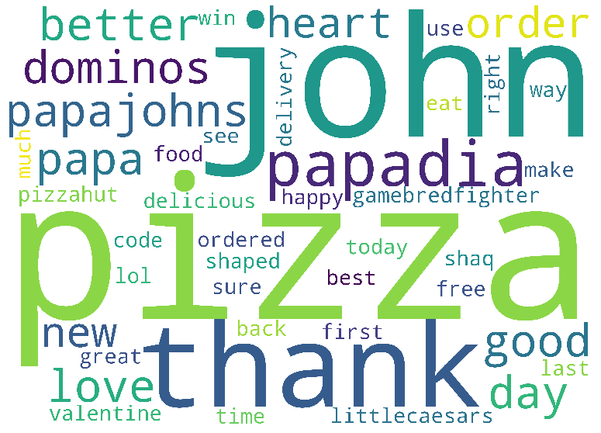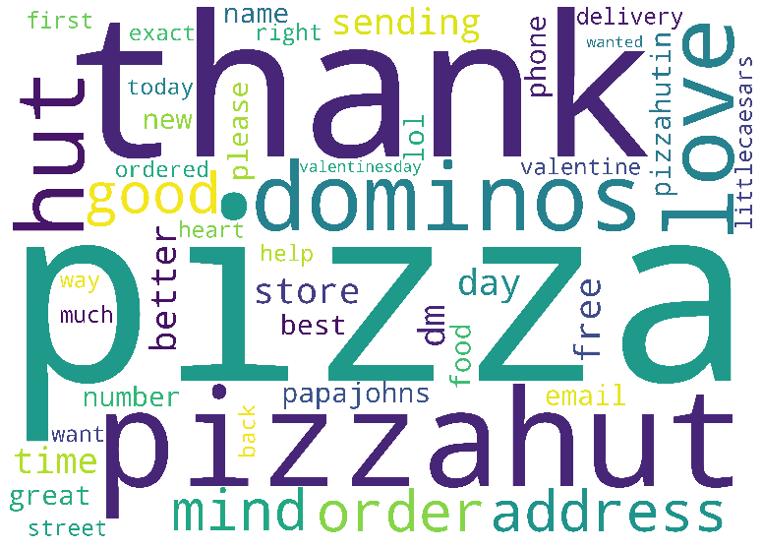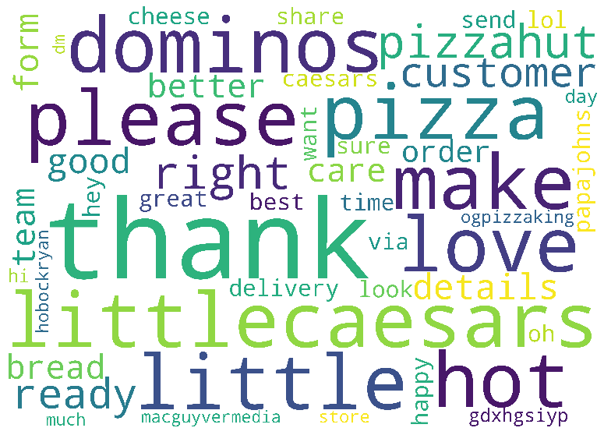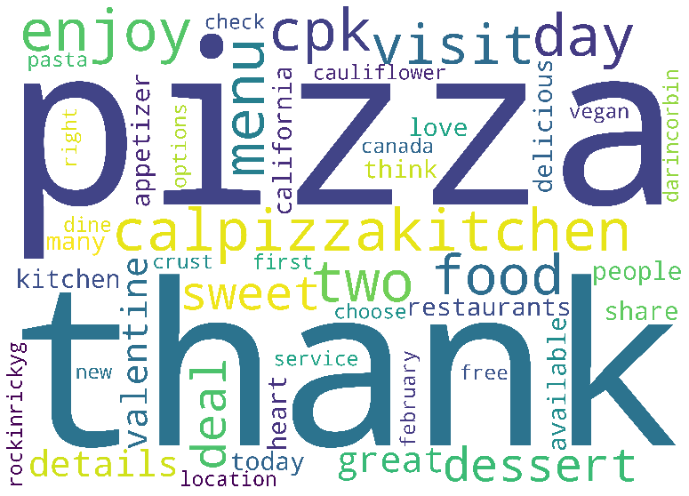

The word clouds above are all the topics that are correlated with positive sentiments towards different brands. Words like thank, best, better, love and share may indicate that customers are satisfied with the service given by all these companies.

**Negative sentiment**: From top left (Pizza Hut, Papa John and Little Caesar)

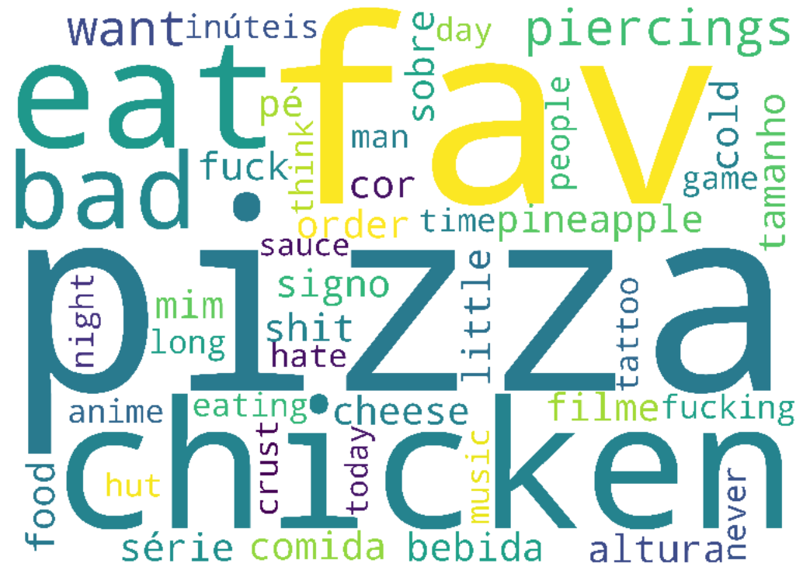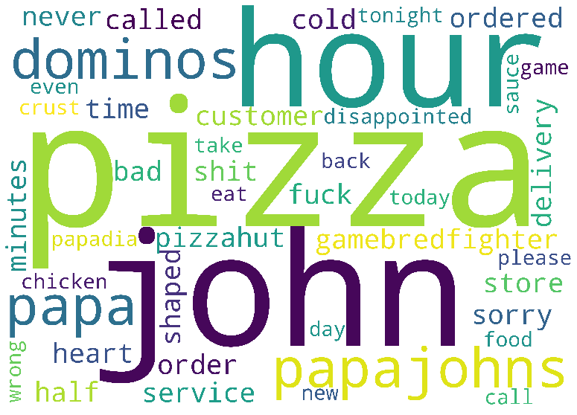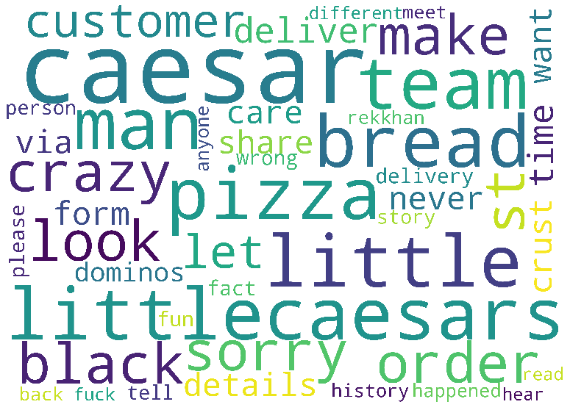

These three word clouds represent the frequent words that has been a topic associated with negative sentiments. Words like hour, long, never, called maybe is a sign that people are complaining about the delivery service given that took ages to arrive. Word like bread, sauce, shit, crust is the negative topic that maybe the customer is complaining about the pizza taste that does not meet their taste.

## Dominos Discussed Topics

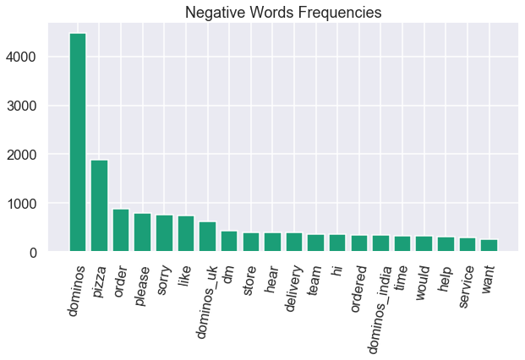

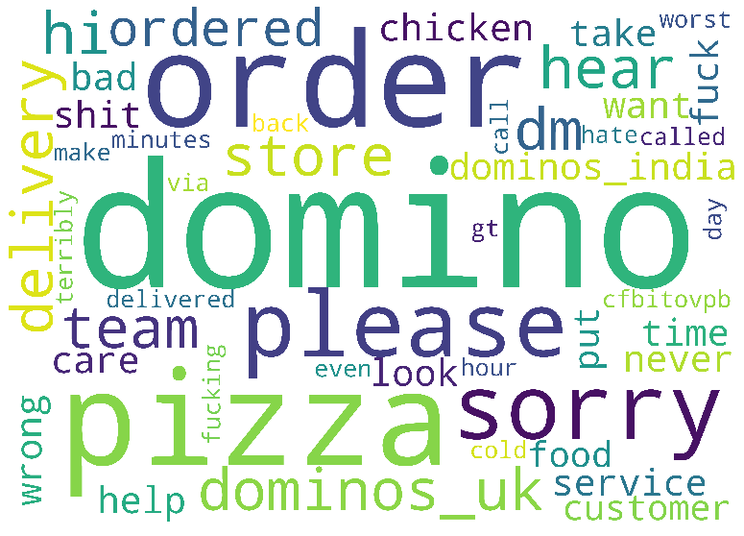

From the frequency table and word cloud above, words like sorry, hear, delivery, time, worst, hate and fuck would indicate that someone is complaining about their services, maybe a bad or slow service that dissatisfied the customer. From here, Dominos can try to improve things from their services and delivery time based on the feedback given by the customer.

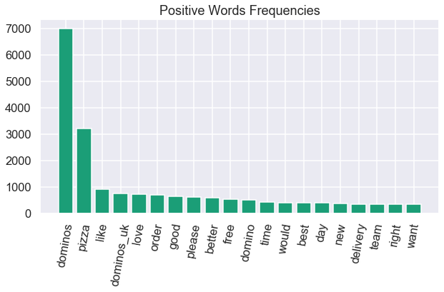

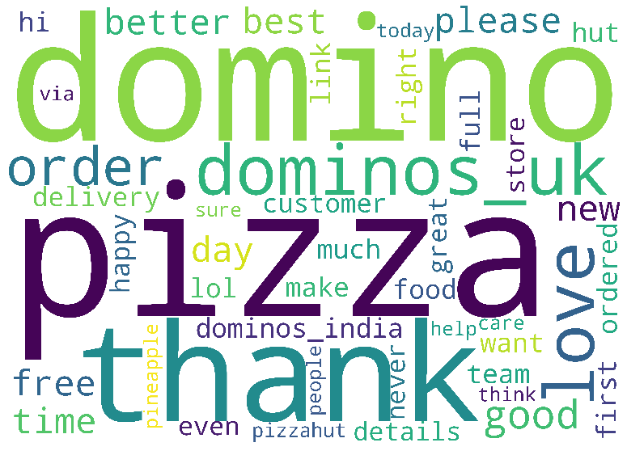

For the positive words frequency, words like love, order, good, better and best indicates that the customer is happy with the service given by Domino's team. The word free, want, full and store may be the indication that the customer is talking about the promotion offered by Dominos and probably they are sharing the promotion with their friends because everyone likes promotion.